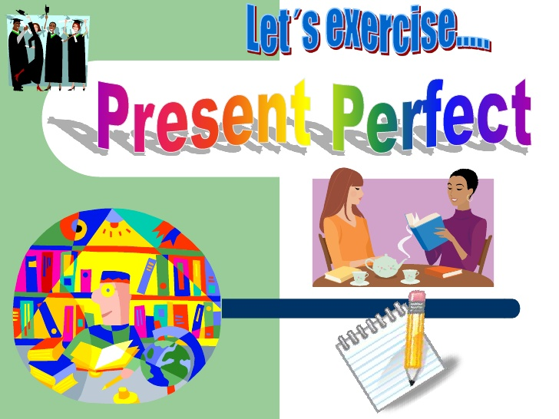
PRESENT PERFECT SIMPLE (test)
1) Write the past participle of the verbs.
1. carry______________
2. go ______________
3. break ______________
4. catch ______________
5. choose ______________
6. keep ______________
7. draw ______________
8. teach ______________
9. write ______________ 9

have/has + V-3/V-ed
have/has + V-3/V-ed

2) Underline the correct words in italics.
1. Sarah has/have never tasted Japanese food.
2. I haven’t live/lived in the city before now.
3. Have your parents ever visited Spain? Yes, they do/have.
4. Have/Has Mary ever stayed in any hotels? Yes, several times.
5. Has Sam ever played golf? No, he hasn’t/doesn’t. 5

3) Fill in the gaps with the verbs in the present perfect.
1. My friend Ted _____________ (spend) a lot of money on gadgets.
2. My father _______________ (not/buy) a new car.
3. The students _______________ (write) a lot of tests this term.
4. I _____________________ (travel) a lot.
5. They ___________________ (not/have) lunch this morning. 5
5

4) Choose been or gone.
1. ‘Where is Pamela?’ ‘She’s been/gone home.
2. ‘Do you like Berlin?’ ‘Yes. I’ve been/gone there twice and I love it.’
3. Jane’s been/gone to the dentist and now she’s going shopping.
4. Nick and Ann aren’t here. They’ve been/gone to the cinema.
5. Alan’s been/gone at the gym. He feels exhausted. 5

5) Complete the sentences. Use for or since.
1. We haven’t watched TV __________ Monday.
2. The boy hasn’t eaten anything ______ six hours.
3. I’ve known Pam ___________ primary school.
4. What have you done ______you finished school?
5. We have studied Chinese ______ three years. 5
6) Make questions using these words.
1. you / visited / Have / ever / Paris ?
_________________________________
2. your dad / ever / Has / anything / invented ?
__________________________________________________________________
3. watched / the best / What’s / you / have / film / ever ?
__________________________________________________________________
4. lived / Jeremy / in / How long / has / Oxford ?
__________________________________________________________________
5. you / the most / book / interesting / have / ever / What’s / read ?
__________________________________________________________________
1010

7) Choose just, yet or already.
1. He is here now. He has just/already/yet arrived.
2. Has Paul started his new job just/already/yet?
3. Their plane has not landed just/already/yet?
4. Ned has just/already/yet fed his pets.
5. Her hair’s wet. She’s just/already/yet washed it.
6. They have just/already/yet visited a lot of countries.
6

Total: 45
KEY

1) 1 carried 2 gone 3 broken 4 caught 5 chosen 6 kept 7 drawn 8 taught 9 written

2) 1 has 2 lived 3 have 4 Has 5 hasn’t

3) 1 has spent 2 hasn’t bought 3 have written 4 have travelled 5 haven’t had

4) 1 gone 2 been 3 been 4 gone 5 been

5) 1 since 2 for 3 since 4 since 5 for

6)
1. Have you ever visited Paris?
2. Has your dad ever invented anything?
3. What’s the best film you have ever watched?
4. How long has Jeremy lived in Oxford?
5. What’s the most interesting book you have ever read?

7) 1 just 2 yet 3 yet 4 already 5 just 6 already

